**football website**

**a web programming i project**

**By**

**Rupesh mahat(8659/18)**

**Sabin mainali(8661/18)**

**Anup khatri(8627/18)**



**Submitted to:**

**Indra pc**

**Department of Computer Science**

**Kantipur College of Management and Information Technology**

**In partial fulfillment of the requirements for the Course**

**Web programming i**

**Mid Baneshwor, Kathmandu**

**December 2021**

**ACKNOWLEDGEMENT**

First of all, I am very glad towards my entire respondent for their valuable information, without whom this would have been incomplete.

The satisfaction that accompanies that the successful completion of any task would be incomplete without the mention of people whose ceaseless cooperation made it possible, whose constant guidance and encouragement crown all efforts with success. We are grateful to our project guide Mr. Indra PC for the guidance, inspiration and constructive suggestions that helpful us in the preparation of this project. We also thank our colleagues who have helped in successful completion of the project

preface

The project is about football website... The report provides the basic knowledge of database and web programming in which different technologies such as PHP, HTML, CSS, Database Server and JavaScript is used. The report is organized in four chapters’ including introduction, requirements and design, development and testing, and conclusion. Introduction chapter describes about existing system and developed system, advantage of developed system over existing system. Chapter two describes requirements that are fulfilled by system and how those requirements are fulfilled. Third chapter insights about development stages and testing work. Final chapter is conclusion which concludes the report

# CHAPTER 1

# INTRODUCTION

Our website system developed for booking and providing news, of football games. The information is sorted and evaluated by the administration. This system will also help in evaluating website eligibility criteria of a football. The purpose of developing this website is to computerized the tradition way of the online booking. Another purpose for developing this system is to generate the report automatically at the end of the session or in the between of the session.

## 1.1. Existing System Introduction

In the meantime, the website is done in the laptop. The website of whole session is done in sheet and at the end the report is generated. The system has become old. In this technological period the work should be quick, effective, relevant etc. The old system might not provide the requirement that the users want.

## 1.2. Disadvantages of Existing System

## 1. Not User Friendly in offline:

The existing system is not user friendly in offline. It can’t give the full satisfaction to the users. Users wants modern techniques.

## 2. Difficult in Report Generating:

We require more calculations to generate the report so it is generated at the end of the month. And the student not get a single chance to improve their attendance.

## 3. Manual Control:

All the report generating work is done manually. There is a greater possibility of errors in the report.

## 1.3. Characteristics of Proposed System

## 1. User Friendly:

The proposed system is user friendly because the retrieval and storing of data is fast and data is maintained efficiently. Moreover, the graphical user interface is provided in the proposed system, which provides user to deal with the system very easily

## . 2. Reports are easily generated:

Reports can be easily generated in the proposed system so user can generate the report as per the requirement (monthly) or in the middle of the session. User can give the notice to the students so he/she become regular.

3. Computer Control:

Computer performs the whole process so there is no chance of any errors. Moreover, storing and retrieving of information is easy. So, work can be done speedily and in time.

## 4. Less of Paperwork’s:

The proposed system requires very less paper work. All the data is feted into the computer immediately and reports can be generated through computers. Moreover, work become very easy because there is no need to keep data on papers.

## Limitations of the Proposed System

1. The scope of the proposed system is the computer on which the system is installed.

2. System is developed only for the desktops, laptops and mobile.

3. For the certain time the system works for the local server only, after a certain this system will be operating offline also.

# CHAPTER 2

## REQUIREMENT AND DESIGN

Website has mainly two modules for functioning: First Module is for Super Admin, person who see website(audience).

## 2.1. Requirements

1.downloadable website.

2.it provides signup if the audience.

3.. booking system form is available.

4.notice is added.

# CHAPTER 3

# DEVELOPMENT AND TESTING

3.1. Development

1. Login Form The login form is for security purpose.

Only the authorized user is allowed to proceed further

## Figure

3. 1: details forms



3. 2:audience login form

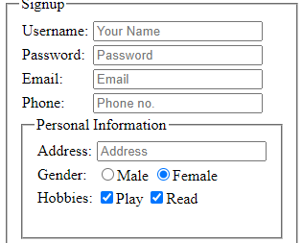

3.2. Testing

The system has been tested with some data’s to view whether it is errorfree or not.

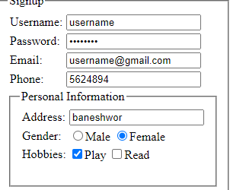

# CHAPTER 4

## CONCLUSION

The system that is developed is simple, efficient and user friendly. It is understandable so any user can take the benefits of it. The extra skill or anything is not needed to use the system. The system is errorfree. It provides all the facilities that is mentioned above.